ITUE203: WEB DEVELOPMENT FRAMEWORKS 25CS106– Yana


Faculty of Technology and Engineering

Chandubhai S. Patel Institute of Technology (CSPIT) Department of Computer Science & Engineering

Laboratory manual
Academic Year | : | 2026-27 | Semester | : | 3rd

Practical - 03

PROBLEM STATEMENT :
Design responsive layouts for Home, About, Registration, Dashboard, and Events pages using CSS Grid and Flexbox. Optional to use CSS framework such as Bootstrap or Tailwind. Ensure mobile-first responsiveness.

OBJECTIVE:
To design and develop a static, multi-page StudentHub website using HTML5 semantic elements while following accessibility best practices, maintaining a consistent page structure, and enabling navigation between pages. The practical aims to help students create clean, organized, and accessibility-ready web page skeletons using semantic HTML tags and proper content hierarchy.

Index:
CODE:
//1
<!DOCTYPE html>
<html lang="en">

<head>
<meta charset="UTF-8">
<meta name="viewport" content="width=device-width, initial-scale=1.0">

<title>StudentHub | Home</title>

<link href="https://cdn.jsdelivr.net/npm/bootstrap@5.3.7/dist/css/bootstrap.min.css" rel="stylesheet">

<link rel="stylesheet" href="css/style.css">
</head>

<body>

<a href="#main-content">Skip to Main Content</a>
<header>
<img src="images/logo.jpeg" alt="StudentHub Logo" width="80">
<h1>StudentHub Portal</h1>
<p>Your Gateway to Academic Services</p>
</header>
<nav aria-label="Main Navigation">
<a href="index.html" aria-current="page">Home</a> |
<a href="dashboard.html">Dashboard</a> |
<a href="overview.html">Overview</a> |
<a href="attendance.html">Attendance</a> |
<a href="assignments.html">Assignments</a> |
<a href="events.html">Events</a> |
<a href="hall-ticket.html">Hall Ticket</a> |
<a href="holidays.html">Holidays</a> |
<a href="lost-found.html">Lost & Found</a> |
<a href="suggestions.html">Suggestions</a> |
<a href="login.html">Login</a>
</nav>
<main id="main-content">
<section>
<h2>Welcome to StudentHub</h2>

<p>
StudentHub is a centralized portal that helps students access
academic information, events, assignments, attendance,
holidays, hall tickets, and other campus services from one place.
</p>

</section>
<section>

<h2>Latest Updates</h2>

<article>

<h3>Upcoming Technical Event</h3>

<p>
StudentHub will organize a coding competition next month.
Students are encouraged to participate.
</p>

</article>

<article>

<h3>Assignment Submission Reminder</h3>

<p>
Submit all assignments before the due date through the StudentHub portal.
</p>

</article>

</section>
<aside>

<h2>Quick Links</h2>

<ul>
<li><a href="attendance.html">Attendance</a></li>
<li><a href="assignments.html">Assignments</a></li>
<li><a href="events.html">Events</a></li>
<li><a href="hall-ticket.html">Hall Ticket</a></li>
</ul>

</aside>

</main>
<footer>
<p>&copy; 2026 StudentHub Portal | Developed for Web Technology Practical</p>
</footer>
<script src="https://cdn.jsdelivr.net/npm/bootstrap@5.3.7/dist/js/bootstrap.bundle.min.js"></script>
<script src="js/script.js"></script>

</body>

</html>

OUTPUT:
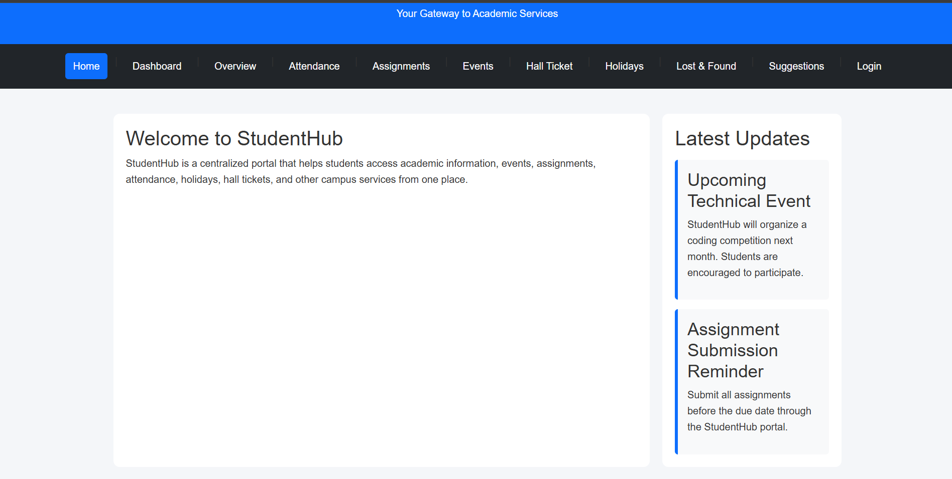
Login:
CODE:
//2
<!DOCTYPE html>
<html lang="en">

<head>
<meta charset="UTF-8">
<meta name="viewport" content="width=device-width, initial-scale=1.0">
<title>StudentHub | Login</title>
<link href="https://cdn.jsdelivr.net/npm/bootstrap@5.3.7/dist/css/bootstrap.min.css" rel="stylesheet">
<link rel="stylesheet" href="css/style.css">
</head>

<body>

<a href="#main-content">Skip to Main Content</a>

<header>
<img src="images/logo.jpeg" alt="StudentHub Portal Logo" width="80">
<h1>StudentHub Portal</h1>
<p>Your Gateway to Academic Services</p>
</header>

<nav aria-label="Main Navigation">
<a href="index.html">Home</a> |
<a href="dashboard.html">Dashboard</a> |
<a href="overview.html">Overview</a> |
<a href="attendance.html">Attendance</a> |
<a href="assignments.html">Assignments</a> |
<a href="events.html">Events</a> |
<a href="hall-ticket.html">Hall Ticket</a> |
<a href="holidays.html">Holidays</a> |
<a href="lost-found.html">Lost & Found</a> |
<a href="suggestions.html">Suggestions</a> |
<a href="login.html" aria-current="page">Login</a>
</nav>

<main id="main-content">

<section>

<h2>Student Login</h2>

<article>

<form action="#" method="post">

<p>
<label for="email">Email Address:</label><br>
<input type="email" id="email" name="email" placeholder="Enter your email" required>
</p>

<p>
<label for="password">Password:</label><br>
<input type="password" id="password" name="password" placeholder="Enter your password" required>
</p>

<p>
<button type="submit">Login</button>
<button type="reset">Reset</button>
</p>

</form>

</article>

</section>

<aside>

<h2>Login Help</h2>

<ul>
<li>Use your registered email address.</li>
<li>Keep your password confidential.</li>
<li>Contact the administrator if you forget your password.</li>
</ul>

</aside>

</main>

<footer>
<p>&copy; 2026 StudentHub Portal | Developed for Web Technology Practical</p>
</footer>
<script src="https://cdn.jsdelivr.net/npm/bootstrap@5.3.7/dist/js/bootstrap.bundle.min.js"></script>
<script src="js/script.js"></script>

</body>

</html>

OUTPUT:
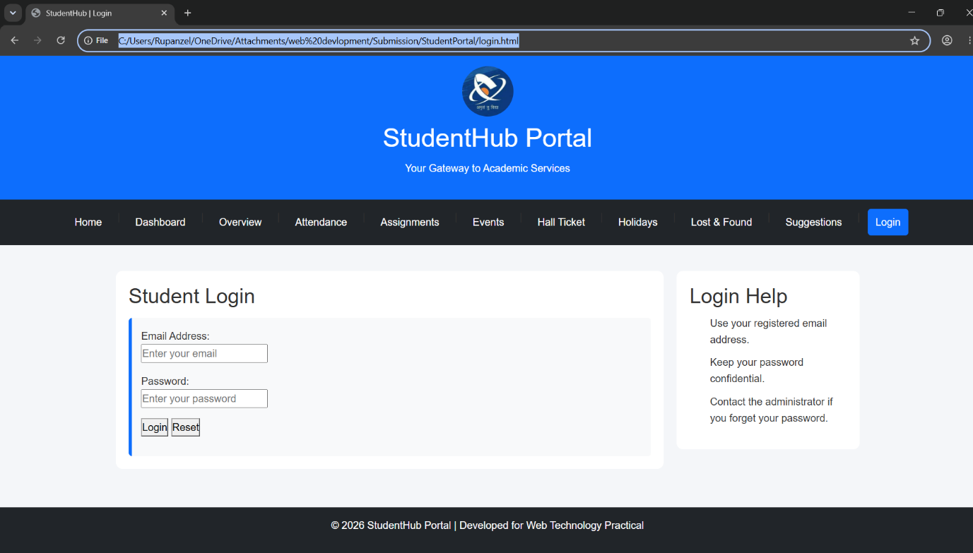
Dashboard:
CODE:
//3
<!DOCTYPE html>
<html lang="en">

<head>
<meta charset="UTF-8">
<meta name="viewport" content="width=device-width, initial-scale=1.0">
<title>StudentHub | Dashboard</title>
<link href="https://cdn.jsdelivr.net/npm/bootstrap@5.3.7/dist/css/bootstrap.min.css" rel="stylesheet">
<link rel="stylesheet" href="css/style.css">
</head>

<body>

<a href="#main-content">Skip to Main Content</a>

<header>
<img src="images/logo.jpeg" alt="StudentHub Portal Logo" width="80">
<h1>StudentHub Portal</h1>
<p>Your Gateway to Academic Services</p>
</header>

<nav aria-label="Main Navigation">
<a href="index.html">Home</a> |
<a href="dashboard.html" aria-current="page">Dashboard</a> |
<a href="overview.html">Overview</a> |
<a href="attendance.html">Attendance</a> |
<a href="assignments.html">Assignments</a> |
<a href="events.html">Events</a> |
<a href="hall-ticket.html">Hall Ticket</a> |
<a href="holidays.html">Holidays</a> |
<a href="lost-found.html">Lost & Found</a> |
<a href="suggestions.html">Suggestions</a> |
<a href="login.html">Login</a>
</nav>

<main id="main-content">

<section>
<h2>Student Dashboard</h2>

<p>
Welcome to your dashboard. Here you can access all academic
services and student information.
</p>
</section>

<section>

<h2>Dashboard Features</h2>

<article>
<h3>Attendance</h3>
<p>View your attendance records and percentage.</p>
</article>

<article>
<h3>Assignments</h3>
<p>Check pending and submitted assignments.</p>
</article>

<article>
<h3>Events</h3>
<p>View upcoming college events and activities.</p>
</article>

</section>

<aside>

<h2>Quick Access</h2>

<ul>
<li><a href="attendance.html">Attendance</a></li>
<li><a href="assignments.html">Assignments</a></li>
<li><a href="events.html">Events</a></li>
<li><a href="hall-ticket.html">Hall Ticket</a></li>
</ul>

</aside>

</main>

<footer>
<p>&copy; 2026 StudentHub Portal | Developed for Web Technology Practical</p>
</footer>
<script src="https://cdn.jsdelivr.net/npm/bootstrap@5.3.7/dist/js/bootstrap.bundle.min.js"></script>
<script src="js/script.js"></script>

</body>

</html>

OUTPUT:
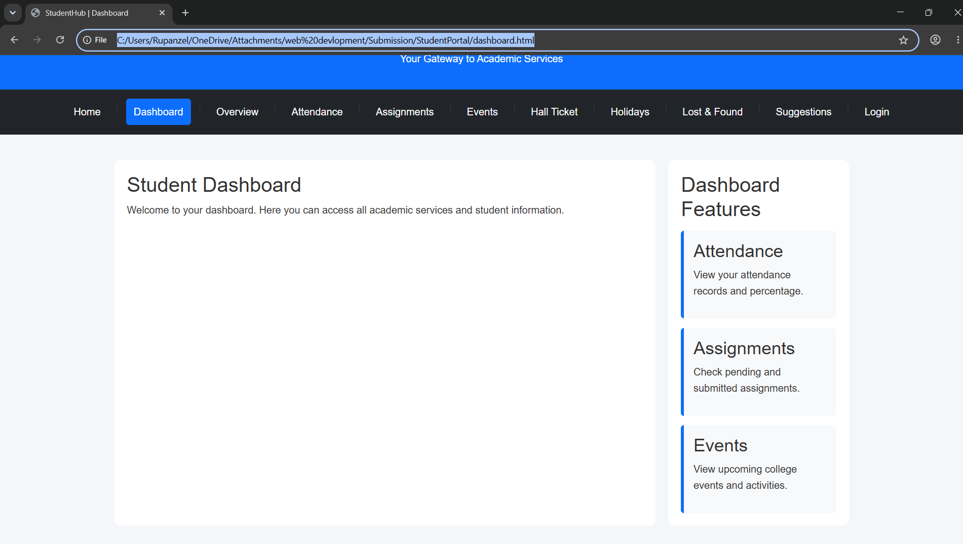
Overview:
CODE:
//4
<!DOCTYPE html>
<html lang="en">

<head>
<meta charset="UTF-8">
<meta name="viewport" content="width=device-width, initial-scale=1.0">
<title>StudentHub | Overview</title>
<link href="https://cdn.jsdelivr.net/npm/bootstrap@5.3.7/dist/css/bootstrap.min.css" rel="stylesheet">
<link rel="stylesheet" href="css/style.css">
</head>

<body>

<a href="#main-content">Skip to Main Content</a>

<header>
<img src="images/logo.jpeg" alt="StudentHub Portal Logo" width="80">
<h1>StudentHub Portal</h1>
<p>Your Gateway to Academic Services</p>
</header>

<nav aria-label="Main Navigation">
<a href="index.html">Home</a> |
<a href="dashboard.html">Dashboard</a> |
<a href="overview.html" aria-current="page">Overview</a> |
<a href="attendance.html">Attendance</a> |
<a href="assignments.html">Assignments</a> |
<a href="events.html">Events</a> |
<a href="hall-ticket.html">Hall Ticket</a> |
<a href="holidays.html">Holidays</a> |
<a href="lost-found.html">Lost & Found</a> |
<a href="suggestions.html">Suggestions</a> |
<a href="login.html">Login</a>
</nav>

<main id="main-content">

<section>
<h2>Student Overview</h2>

<p>
This page provides a summary of your academic progress,
attendance, assignments, events, and other important information.
</p>
</section>

<section>

<h2>Academic Summary</h2>

<article>
<h3>Attendance Status</h3>
<p>Your current attendance percentage is displayed here.</p>
</article>

<article>
<h3>Assignment Progress</h3>
<p>View the status of submitted and pending assignments.</p>
</article>

<article>
<h3>Upcoming Activities</h3>
<p>Check upcoming events, examinations, and important notices.</p>
</article>

</section>

<aside>

<h2>Quick Links</h2>

<ul>
<li><a href="dashboard.html">Dashboard</a></li>
<li><a href="attendance.html">Attendance</a></li>
<li><a href="assignments.html">Assignments</a></li>
<li><a href="events.html">Events</a></li>
</ul>

</aside>

</main>

<footer>
<p>&copy; 2026 StudentHub Portal | Developed for Web Technology Practical</p>
</footer>
<script src="https://cdn.jsdelivr.net/npm/bootstrap@5.3.7/dist/js/bootstrap.bundle.min.js"></script>
<script src="js/script.js"></script>
</body>

</html>

OUTPUT:
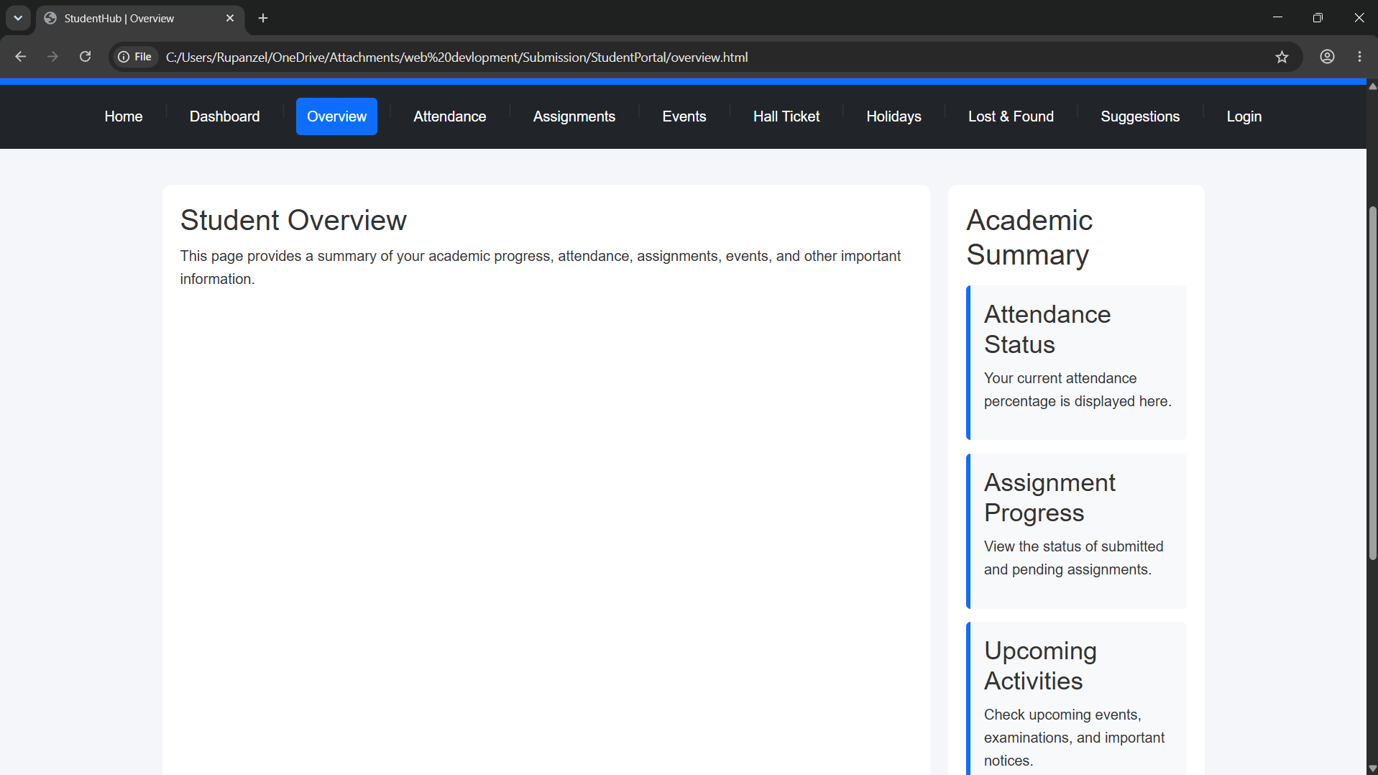
Attendance:
CODE:
//5
<!DOCTYPE html>
<html lang="en">

<head>
<meta charset="UTF-8">
<meta name="viewport" content="width=device-width, initial-scale=1.0">
<title>StudentHub | Attendance</title>
<link href="https://cdn.jsdelivr.net/npm/bootstrap@5.3.7/dist/css/bootstrap.min.css" rel="stylesheet">

<link rel="stylesheet" href="css/style.css">
</head>

<body>

<a href="#main-content">Skip to Main Content</a>

<header>
<img src="images/logo.jpeg" alt="StudentHub Portal Logo" width="80">
<h1>StudentHub Portal</h1>
<p>Your Gateway to Academic Services</p>
</header>

<nav aria-label="Main Navigation">
<a href="index.html">Home</a> |
<a href="dashboard.html">Dashboard</a> |
<a href="overview.html">Overview</a> |
<a href="attendance.html" aria-current="page">Attendance</a> |
<a href="assignments.html">Assignments</a> |
<a href="events.html">Events</a> |
<a href="hall-ticket.html">Hall Ticket</a> |
<a href="holidays.html">Holidays</a> |
<a href="lost-found.html">Lost & Found</a> |
<a href="suggestions.html">Suggestions</a> |
<a href="login.html">Login</a>
</nav>

<main id="main-content">

<section>
<h2>Attendance Record</h2>

<p>
This page displays your attendance details for all registered
courses during the current semester.
</p>
</section>

<section>

<h2>Attendance Summary</h2>

<article>

<h3>Current Attendance</h3>

<table border="1">

<caption>Attendance Details</caption>

<thead>
<tr>
<th>Subject</th>
<th>Classes Held</th>
<th>Classes Attended</th>
<th>Attendance (%)</th>
</tr>
</thead>

<tbody>
<tr>
<td>Web Technology</td>
<td>30</td>
<td>28</td>
<td>93%</td>
</tr>

<tr>
<td>Data Structures</td>
<td>32</td>
<td>30</td>
<td>94%</td>
</tr>

<tr>
<td>Operating Systems</td>
<td>28</td>
<td>27</td>
<td>96%</td>
</tr>
</tbody>

</table>

</article>

</section>

<aside>

<h2>Important Note</h2>

<p>
Students must maintain a minimum attendance of 75% to appear
for the semester examinations.
</p>

</aside>

</main>

<footer>
<p>&copy; 2026 StudentHub Portal | Developed for Web Technology Practical</p>
</footer>
<script src="https://cdn.jsdelivr.net/npm/bootstrap@5.3.7/dist/js/bootstrap.bundle.min.js"></script>
<script src="js/script.js"></script>
</body>

</html>

OUTPUT:
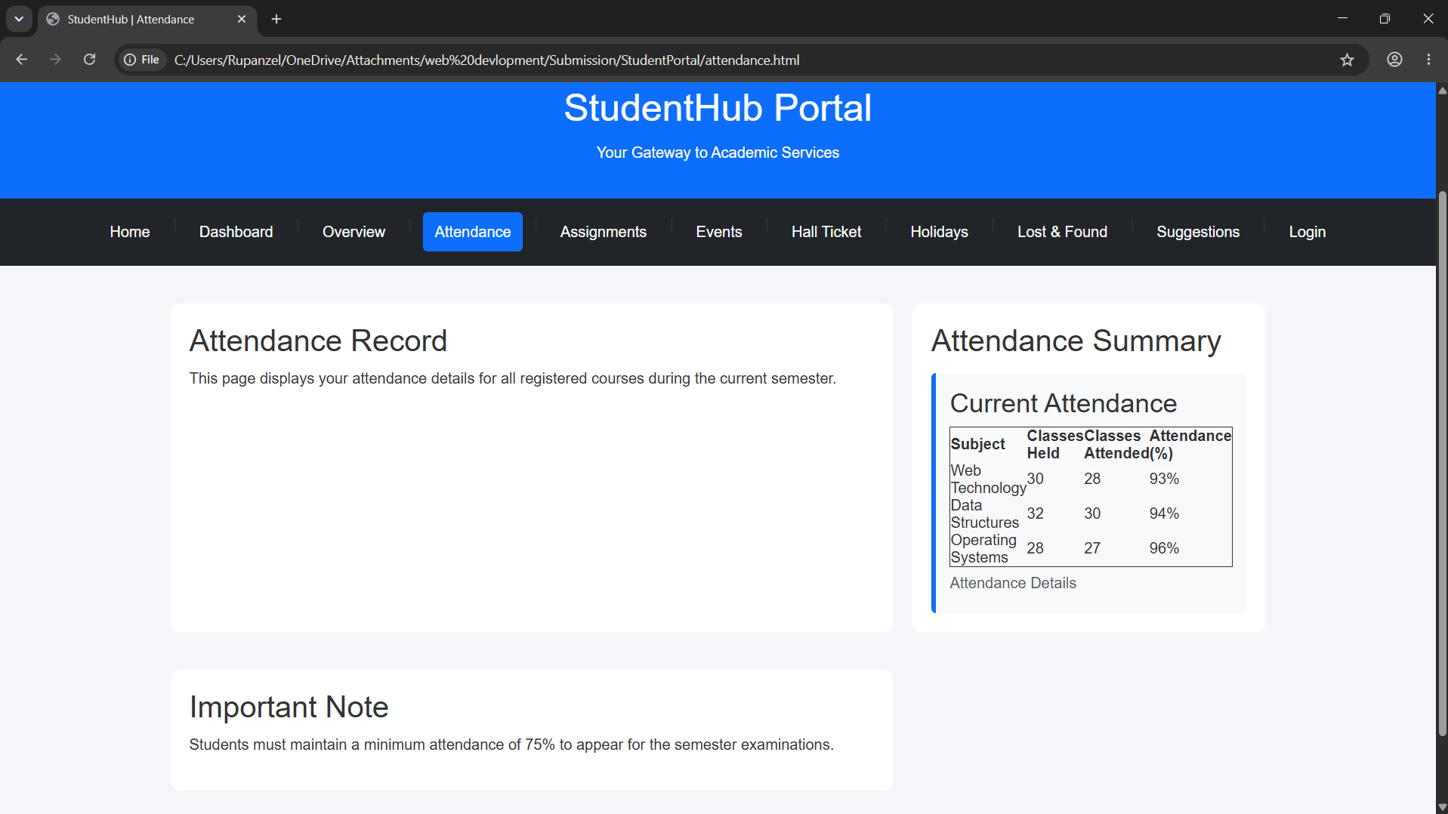
Assignment:

CODE:
//6
<!DOCTYPE html>
<html lang="en">

<head>
<meta charset="UTF-8">
<meta name="viewport" content="width=device-width, initial-scale=1.0">
<title>StudentHub | Assignments</title>

<link href="https://cdn.jsdelivr.net/npm/bootstrap@5.3.7/dist/css/bootstrap.min.css" rel="stylesheet">
<link rel="stylesheet" href="css/style.css">
</head>

<body>

<a href="#main-content">Skip to Main Content</a>

<header>
<img src="images/logo.jpeg" alt="StudentHub Portal Logo" width="80">
<h1>StudentHub Portal</h1>
<p>Your Gateway to Academic Services</p>
</header>

<nav aria-label="Main Navigation">
<a href="index.html">Home</a> |
<a href="dashboard.html">Dashboard</a> |
<a href="overview.html">Overview</a> |
<a href="attendance.html">Attendance</a> |
<a href="assignments.html" aria-current="page">Assignments</a> |
<a href="events.html">Events</a> |
<a href="hall-ticket.html">Hall Ticket</a> |
<a href="holidays.html">Holidays</a> |
<a href="lost-found.html">Lost & Found</a> |
<a href="suggestions.html">Suggestions</a> |
<a href="login.html">Login</a>
</nav>

<main id="main-content">

<section>
<h2>Assignments</h2>

<p>
This page displays all assignments assigned to students along
with their submission status.
</p>
</section>

<section>

<h2>Assignment Details</h2>

<article>

<h3>Current Assignments</h3>

<table border="1">

<caption>Assignment Status</caption>

<thead>
<tr>
<th>Subject</th>
<th>Assignment</th>
<th>Due Date</th>
<th>Status</th>
</tr>
</thead>

<tbody>

<tr>
<td>Web Technology</td>
<td>HTML5 Practical</td>
<td>30 July 2026</td>
<td>Submitted</td>
</tr>

<tr>
<td>Data Structures</td>
<td>Linked List Program</td>
<td>05 August 2026</td>
<td>Pending</td>
</tr>

<tr>
<td>Operating Systems</td>
<td>Process Scheduling Report</td>
<td>08 August 2026</td>
<td>In Progress</td>
</tr>

</tbody>

</table>

</article>

</section>

<aside>

<h2>Assignment Guidelines</h2>

<ul>
<li>Submit assignments before the due date.</li>
<li>Upload only PDF or ZIP files.</li>
<li>Late submissions may receive reduced marks.</li>
<li>Check plagiarism before submission.</li>
</ul>

</aside>

</main>

<footer>
<p>&copy; 2026 StudentHub Portal | Developed for Web Technology Practical</p>
</footer>
<script src="https://cdn.jsdelivr.net/npm/bootstrap@5.3.7/dist/js/bootstrap.bundle.min.js"></script>
<script src="js/script.js"></script>

</body>

</html>

OUTPUT:
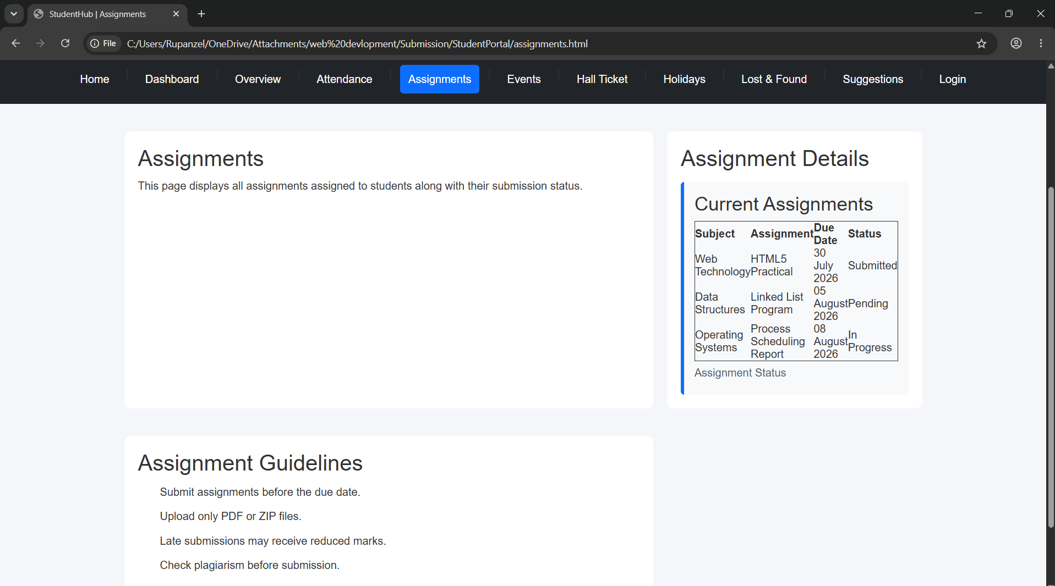
Events:
CODE:
//7
<!DOCTYPE html>
<html lang="en">

<head>
<meta charset="UTF-8">
<meta name="viewport" content="width=device-width, initial-scale=1.0">
<title>StudentHub | Events</title>
<link href="https://cdn.jsdelivr.net/npm/bootstrap@5.3.7/dist/css/bootstrap.min.css" rel="stylesheet">
<link rel="stylesheet" href="css/style.css">
</head>

<body>

<a href="#main-content">Skip to Main Content</a>

<header>
<img src="images/logo.jpeg" alt="StudentHub Portal Logo" width="80">
<h1>StudentHub Portal</h1>
<p>Your Gateway to Academic Services</p>
</header>

<nav aria-label="Main Navigation">
<a href="index.html">Home</a> |
<a href="dashboard.html">Dashboard</a> |
<a href="overview.html">Overview</a> |
<a href="attendance.html">Attendance</a> |
<a href="assignments.html">Assignments</a> |
<a href="events.html" aria-current="page">Events</a> |
<a href="hall-ticket.html">Hall Ticket</a> |
<a href="holidays.html">Holidays</a> |
<a href="lost-found.html">Lost & Found</a> |
<a href="suggestions.html">Suggestions</a> |
<a href="login.html">Login</a>
</nav>

<main id="main-content">

<section>
<h2>College Events</h2>

<p>
This page provides information about upcoming college events,
workshops, seminars, competitions, and cultural activities.
</p>
</section>

<section>

<h2>Upcoming Events</h2>

<article>
<h3>Web Development Workshop</h3>
<p><strong>Date:</strong> 12 August 2026</p>
<p><strong>Venue:</strong> CSPIT Seminar Hall</p>
<p>Learn the fundamentals of HTML5, CSS3, and JavaScript.</p>
</article>

<article>
<h3>Hackathon 2026</h3>
<p><strong>Date:</strong> 20 August 2026</p>
<p><strong>Venue:</strong> Innovation Lab</p>
<p>Participate in a 24-hour coding competition and showcase your skills.</p>
</article>

<article>
<h3>Career Guidance Seminar</h3>
<p><strong>Date:</strong> 28 August 2026</p>
<p><strong>Venue:</strong> Auditorium</p>
<p>Industry experts will discuss career opportunities and placement preparation.</p>
</article>

</section>

<aside>

<h2>Event Guidelines</h2>

<ul>
<li>Register before the event deadline.</li>
<li>Carry your student ID card.</li>
<li>Arrive at least 15 minutes early.</li>
<li>Follow college rules during the event.</li>
</ul>

</aside>

</main>

<footer>
<p>&copy; 2026 StudentHub Portal | Developed for Web Technology Practical</p>
</footer>
<script src="https://cdn.jsdelivr.net/npm/bootstrap@5.3.7/dist/js/bootstrap.bundle.min.js"></script>
<script src="js/script.js"></script>
</body>

</html>

OUTPUT:
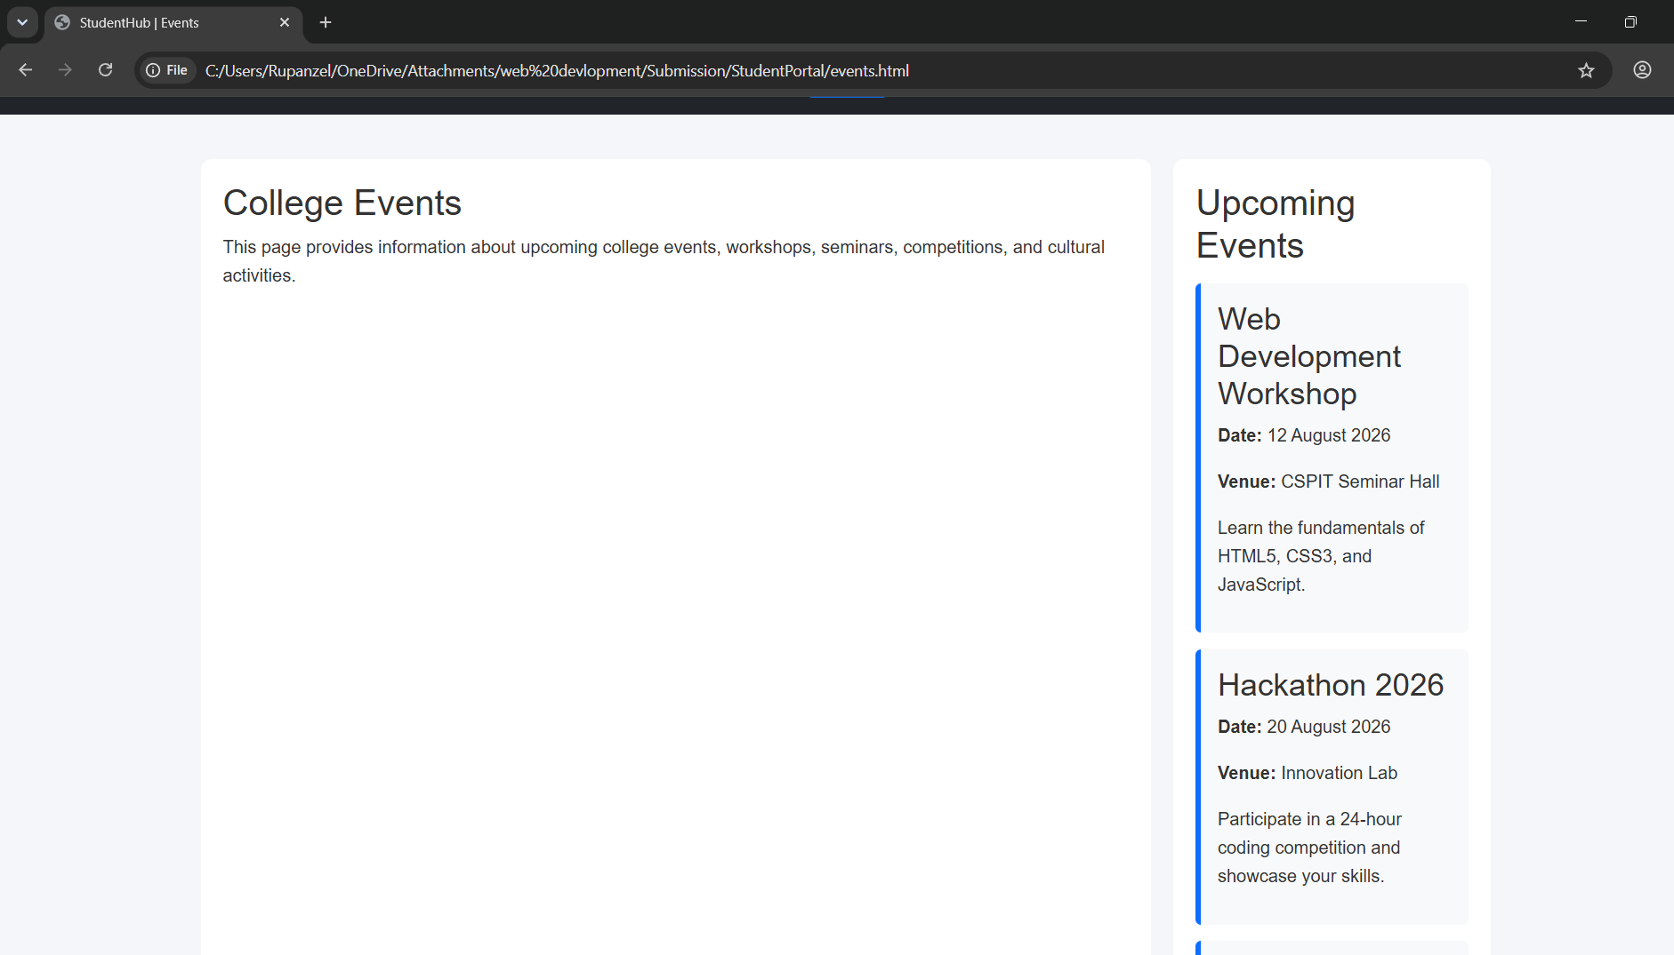
Hall Ticket:
CODE:
//8
<!DOCTYPE html>
<html lang="en">

<head>
<meta charset="UTF-8">
<meta name="viewport" content="width=device-width, initial-scale=1.0">
<title>StudentHub | Hall Ticket</title>
<link href="https://cdn.jsdelivr.net/npm/bootstrap@5.3.7/dist/css/bootstrap.min.css" rel="stylesheet">
<link rel="stylesheet" href="css/style.css">
</head>

<body>

<a href="#main-content">Skip to Main Content</a>

<header>
<img src="images/logo.jpeg" alt="StudentHub Portal Logo" width="80">
<h1>StudentHub Portal</h1>
<p>Your Gateway to Academic Services</p>
</header>

<nav aria-label="Main Navigation">
<a href="index.html">Home</a> |
<a href="dashboard.html">Dashboard</a> |
<a href="overview.html">Overview</a> |
<a href="attendance.html">Attendance</a> |
<a href="assignments.html">Assignments</a> |
<a href="events.html">Events</a> |
<a href="hall-ticket.html" aria-current="page">Hall Ticket</a> |
<a href="holidays.html">Holidays</a> |
<a href="lost-found.html">Lost & Found</a> |
<a href="suggestions.html">Suggestions</a> |
<a href="login.html">Login</a>
</nav>

<main id="main-content">

<section>
<h2>Hall Ticket</h2>

<p>
This page displays the examination hall ticket details for
registered students.
</p>
</section>

<section>

<h2>Student Examination Details</h2>

<article>

<h3>Hall Ticket Information</h3>

<table border="1">

<caption>Examination Hall Ticket</caption>

<thead>
<tr>
<th>Field</th>
<th>Information</th>
</tr>
</thead>

<tbody>
<tr>
<td>Student Name</td>
<td>Yana Thakor</td>
</tr>

<tr>
<td>Enrollment Number</td>
<td>25CS106</td>
</tr>

<tr>
<td>Program</td>
<td>B.Tech Computer Science & Engineering</td>
</tr>

<tr>
<td>Semester</td>
<td>3</td>
</tr>

<tr>
<td>Examination</td>
<td>Mid Semester Examination</td>
</tr>

<tr>
<td>Examination Center</td>
<td>CSPIT, CHARUSAT</td>
</tr>
</tbody>

</table>

</article>

</section>

<aside>

<h2>Instructions</h2>

<ul>
<li>Carry your hall ticket to the examination hall.</li>
<li>Bring your valid student ID card.</li>
<li>Reach the examination center 30 minutes early.</li>
<li>Electronic gadgets are not allowed.</li>
</ul>

</aside>

</main>

<footer>
<p>&copy; 2026 StudentHub Portal | Developed for Web Technology Practical</p>
</footer>
<script src="https://cdn.jsdelivr.net/npm/bootstrap@5.3.7/dist/js/bootstrap.bundle.min.js"></script>
<script src="js/script.js"></script>
</body>

</html>

OUTPUT:
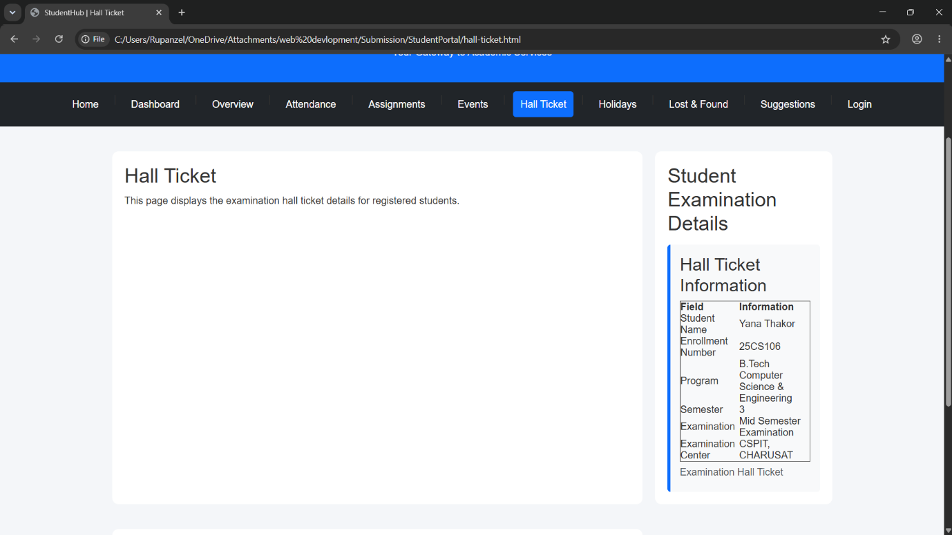
Holidays:
CODE:
//9
<!DOCTYPE html>
<html lang="en">

<head>
<meta charset="UTF-8">
<meta name="viewport" content="width=device-width, initial-scale=1.0">
<title>StudentHub | Holidays</title>
<link href="https://cdn.jsdelivr.net/npm/bootstrap@5.3.7/dist/css/bootstrap.min.css" rel="stylesheet">
<link rel="stylesheet" href="css/style.css">
</head>

<body>

<a href="#main-content">Skip to Main Content</a>

<header>
<img src="images/logo.jpeg" alt="StudentHub Portal Logo" width="80">
<h1>StudentHub Portal</h1>
<p>Your Gateway to Academic Services</p>
</header>

<nav aria-label="Main Navigation">
<a href="index.html">Home</a> |
<a href="dashboard.html">Dashboard</a> |
<a href="overview.html">Overview</a> |
<a href="attendance.html">Attendance</a> |
<a href="assignments.html">Assignments</a> |
<a href="events.html">Events</a> |
<a href="hall-ticket.html">Hall Ticket</a> |
<a href="holidays.html" aria-current="page">Holidays</a> |
<a href="lost-found.html">Lost & Found</a> |
<a href="suggestions.html">Suggestions</a> |
<a href="login.html">Login</a>
</nav>

<main id="main-content">

<section>

<h2>Academic Holidays</h2>

<p>
This page displays the list of official holidays declared by
the college for the academic year.
</p>

</section>

<section>

<h2>Holiday Calendar</h2>

<article>

<h3>List of Holidays</h3>

<table border="1">

<caption>Academic Holiday List</caption>

<thead>
<tr>
<th>Date</th>
<th>Holiday</th>
<th>Day</th>
</tr>
</thead>

<tbody>

<tr>
<td>15 August 2026</td>
<td>Independence Day</td>
<td>Saturday</td>
</tr>

<tr>
<td>02 October 2026</td>
<td>Gandhi Jayanti</td>
<td>Friday</td>
</tr>

<tr>
<td>24 October 2026</td>
<td>Diwali Vacation Begins</td>
<td>Saturday</td>
</tr>

<tr>
<td>25 December 2026</td>
<td>Christmas</td>
<td>Friday</td>
</tr>

</tbody>

</table>

</article>

</section>

<aside>

<h2>Holiday Notice</h2>

<ul>
<li>Holiday dates are subject to university notifications.</li>
<li>Check the notice board regularly for updates.</li>
<li>Classes will resume as per the academic calendar.</li>
</ul>

</aside>

</main>

<footer>
<p>&copy; 2026 StudentHub Portal | Developed for Web Technology Practical</p>
</footer>
<script src="https://cdn.jsdelivr.net/npm/bootstrap@5.3.7/dist/js/bootstrap.bundle.min.js"></script>
<script src="js/script.js"></script>

</body>

</html>

OUTPUT:
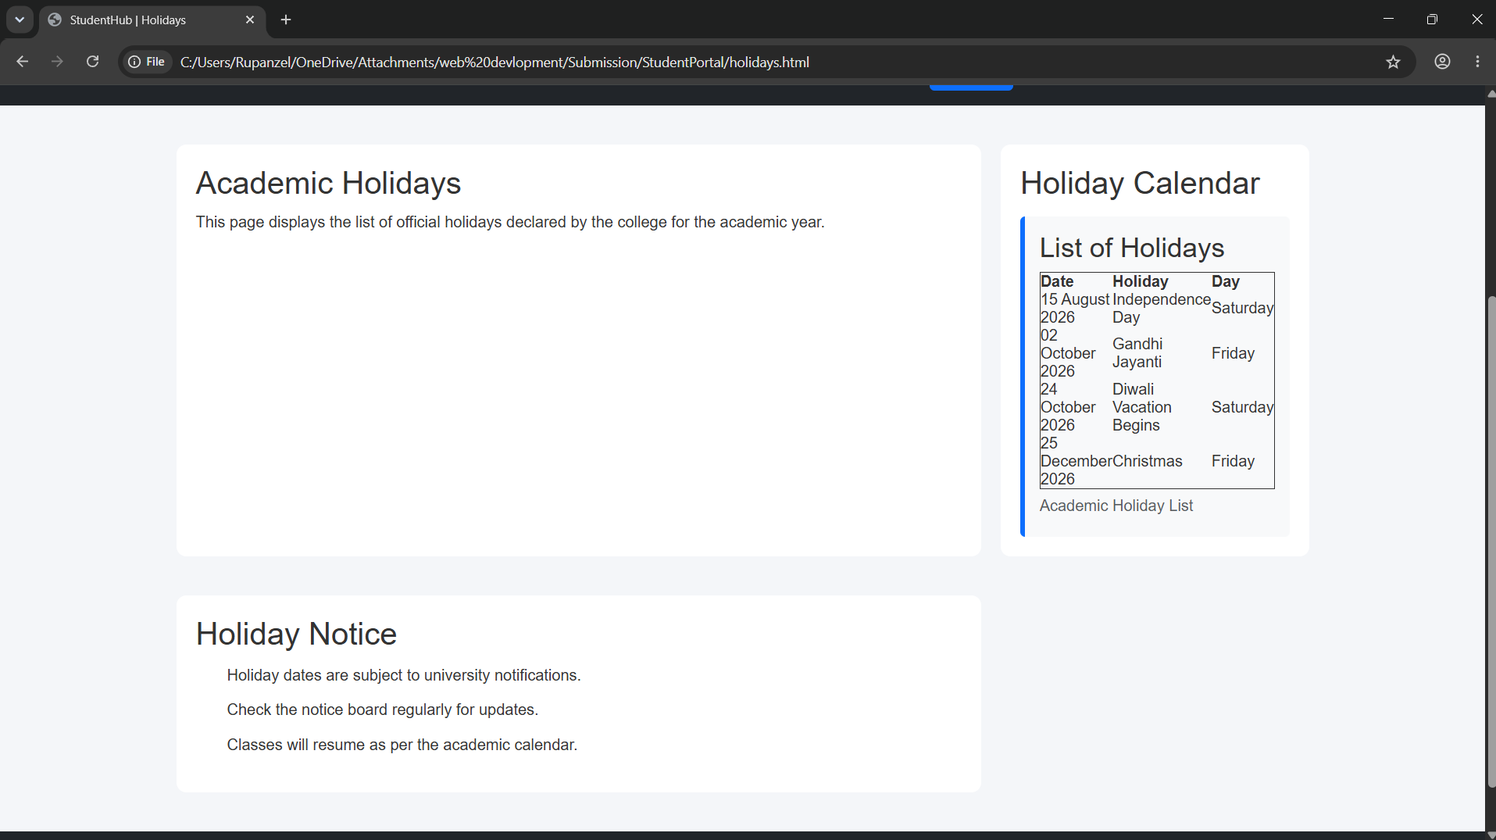
Lost - Found:
CODE:
//10
<!DOCTYPE html>
<html lang="en">

<head>
<meta charset="UTF-8">
<meta name="viewport" content="width=device-width, initial-scale=1.0">
<title>StudentHub | Lost & Found</title>
<link href="https://cdn.jsdelivr.net/npm/bootstrap@5.3.7/dist/css/bootstrap.min.css" rel="stylesheet">
<link rel="stylesheet" href="css/style.css">
</head>

<body>

<a href="#main-content">Skip to Main Content</a>

<header>
<img src="images/logo.jpeg" alt="StudentHub Portal Logo" width="80">
<h1>StudentHub Portal</h1>
<p>Your Gateway to Academic Services</p>
</header>

<nav aria-label="Main Navigation">
<a href="index.html">Home</a> |
<a href="dashboard.html">Dashboard</a> |
<a href="overview.html">Overview</a> |
<a href="attendance.html">Attendance</a> |
<a href="assignments.html">Assignments</a> |
<a href="events.html">Events</a> |
<a href="hall-ticket.html">Hall Ticket</a> |
<a href="holidays.html">Holidays</a> |
<a href="lost-found.html" aria-current="page">Lost & Found</a> |
<a href="suggestions.html">Suggestions</a> |
<a href="login.html">Login</a>
</nav>

<main id="main-content">

<section>

<h2>Lost & Found</h2>

<p>
Report a lost or found item using the form below.
</p>

</section>

<section>

<h2>Report an Item</h2>

<article>

<form action="#" method="post">

<p>
<label for="student-name">Student Name:</label><br>
<input type="text" id="student-name" name="student-name" required>
</p>

<p>
<label for="item-name">Item Name:</label><br>
<input type="text" id="item-name" name="item-name" required>
</p>

<p>
<label for="status">Status:</label><br>
<select id="status" name="status">
<option>Lost</option>
<option>Found</option>
</select>
</p>

<p>
<label for="description">Description:</label><br>
<textarea id="description" name="description" rows="5" cols="40"></textarea>
</p>

<p>
<button type="submit">Submit Report</button>
<button type="reset">Reset</button>
</p>

</form>

</article>

</section>

<aside>

<h2>Instructions</h2>

<ul>
<li>Provide accurate item details.</li>
<li>Mention where the item was lost or found.</li>
<li>Contact the administration office for verification.</li>
<li>Carry your student ID while collecting an item.</li>
</ul>

</aside>

</main>

<footer>
<p>&copy; 2026 StudentHub Portal | Developed for Web Technology Practical</p>
</footer>
<script src="https://cdn.jsdelivr.net/npm/bootstrap@5.3.7/dist/js/bootstrap.bundle.min.js"></script>
<script src="js/script.js"></script>

</body>

</html>
OUTPUT:
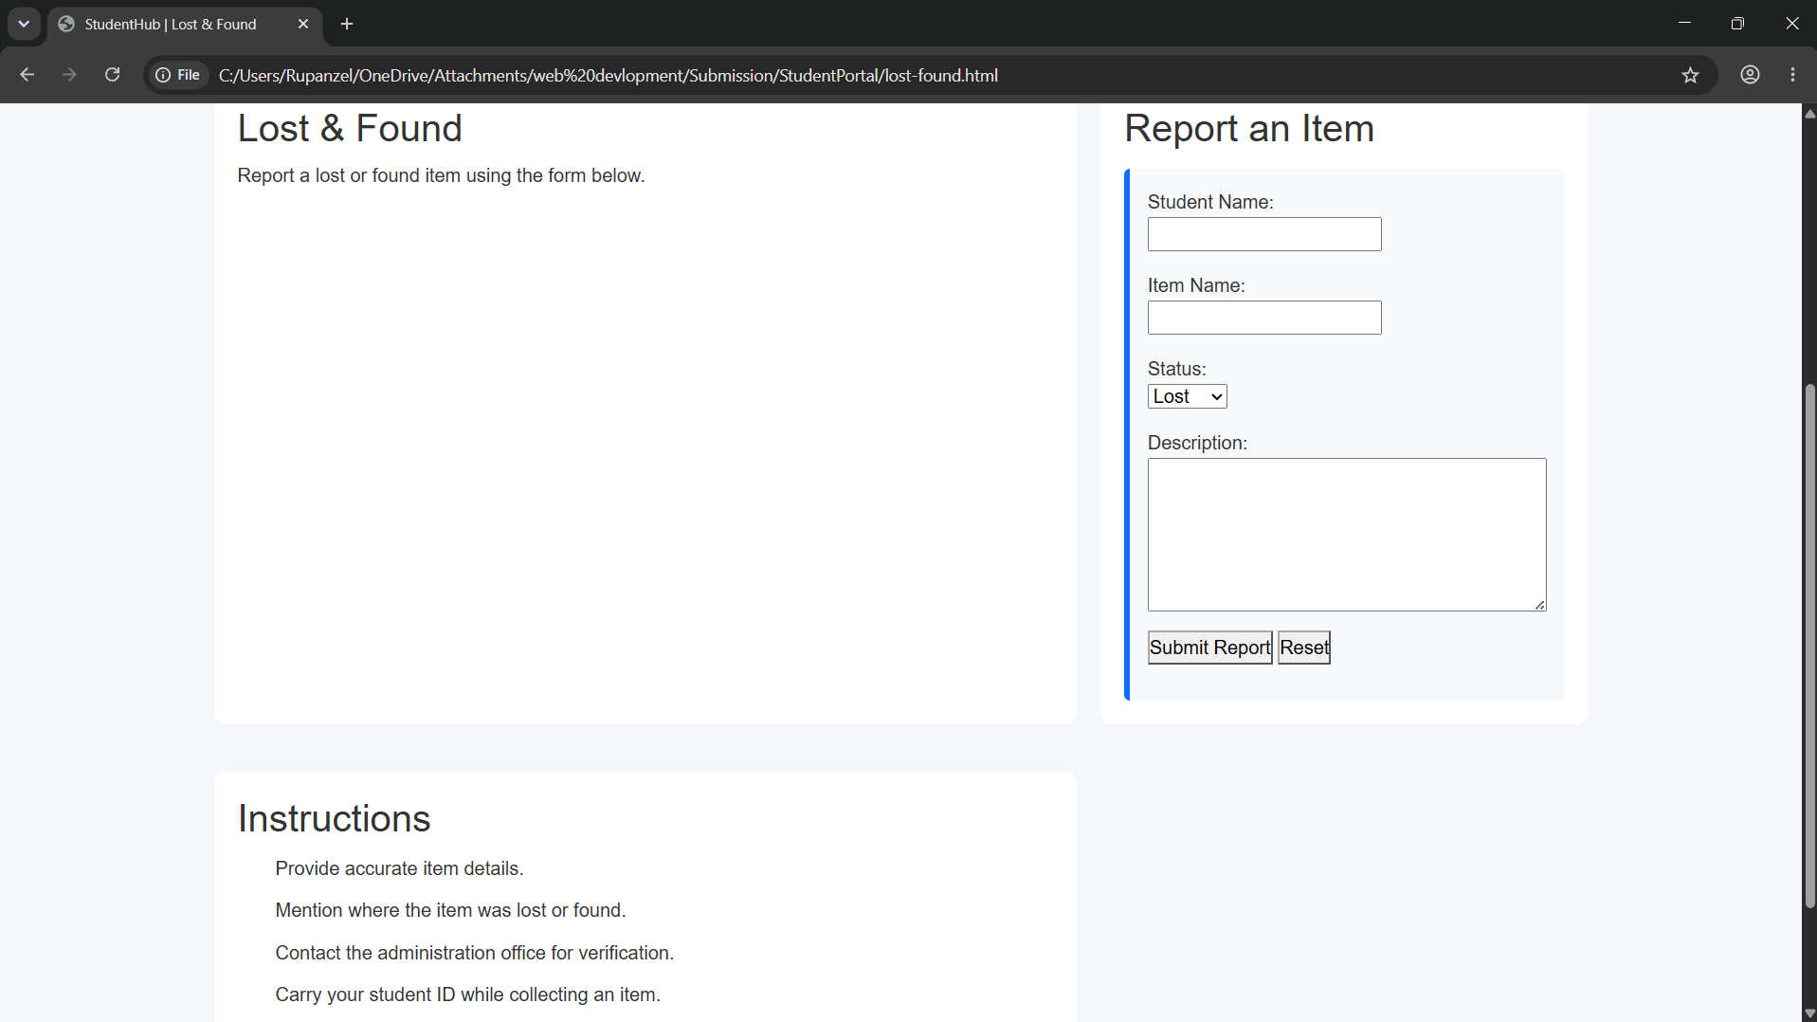

Suggestions:
CODE:
//11
<!DOCTYPE html>
<html lang="en">

<head>
<meta charset="UTF-8">
<meta name="viewport" content="width=device-width, initial-scale=1.0">
<title>StudentHub | Suggestions</title>
<link href="https://cdn.jsdelivr.net/npm/bootstrap@5.3.7/dist/css/bootstrap.min.css" rel="stylesheet">
<link rel="stylesheet" href="css/style.css">
</head>

<body>

<a href="#main-content">Skip to Main Content</a>

<header>
<img src="images/logo.jpeg" alt="StudentHub Portal Logo" width="80">
<h1>StudentHub Portal</h1>
<p>Your Gateway to Academic Services</p>
</header>

<nav aria-label="Main Navigation">
<a href="index.html">Home</a> |
<a href="dashboard.html">Dashboard</a> |
<a href="overview.html">Overview</a> |
<a href="attendance.html">Attendance</a> |
<a href="assignments.html">Assignments</a> |
<a href="events.html">Events</a> |
<a href="hall-ticket.html">Hall Ticket</a> |
<a href="holidays.html">Holidays</a> |
<a href="lost-found.html">Lost & Found</a> |
<a href="suggestions.html" aria-current="page">Suggestions</a> |
<a href="login.html">Login</a>
</nav>

<main id="main-content">

<section>
<h2>Suggestions & Feedback</h2>

<p>
We value your feedback. Please share your suggestions to help
improve the StudentHub portal and campus services.
</p>

</section>

<section>

<h2>Submit Your Feedback</h2>

<article>

<form action="#" method="post">

<p>
<label for="student-name">Student Name:</label><br>
<input
type="text"
id="student-name"
name="student-name"
placeholder="Enter your name"
required>
</p>

<p>
<label for="email">Email Address:</label><br>
<input
type="email"
id="email"
name="email"
placeholder="Enter your email"
required>
</p>

<p>
<label for="category">Suggestion Category:</label><br>
<select id="category" name="category">
<option>Academic</option>
<option>Events</option>
<option>Facilities</option>
<option>Website</option>
<option>Other</option>
</select>
</p>

<p>
<label for="feedback">Your Suggestion:</label><br>
<textarea
id="feedback"
name="feedback"
rows="6"
cols="40"
placeholder="Write your suggestion here..."
required></textarea>
</p>

<p>
<button type="submit">Submit</button>
<button type="reset">Reset</button>
</p>

</form>

</article>

</section>

<aside>

<h2>Feedback Guidelines</h2>

<ul>
<li>Provide clear and constructive suggestions.</li>
<li>Avoid inappropriate language.</li>
<li>Include relevant details when reporting issues.</li>
<li>Your feedback helps improve StudentHub.</li>
</ul>

</aside>

</main>

<footer>
<p>&copy; 2026 StudentHub Portal | Developed for Web Technology Practical</p>
</footer>
<script src="https://cdn.jsdelivr.net/npm/bootstrap@5.3.7/dist/js/bootstrap.bundle.min.js"></script>
<script src="js/script.js"></script>

</body>

</html>
OUTPUT:
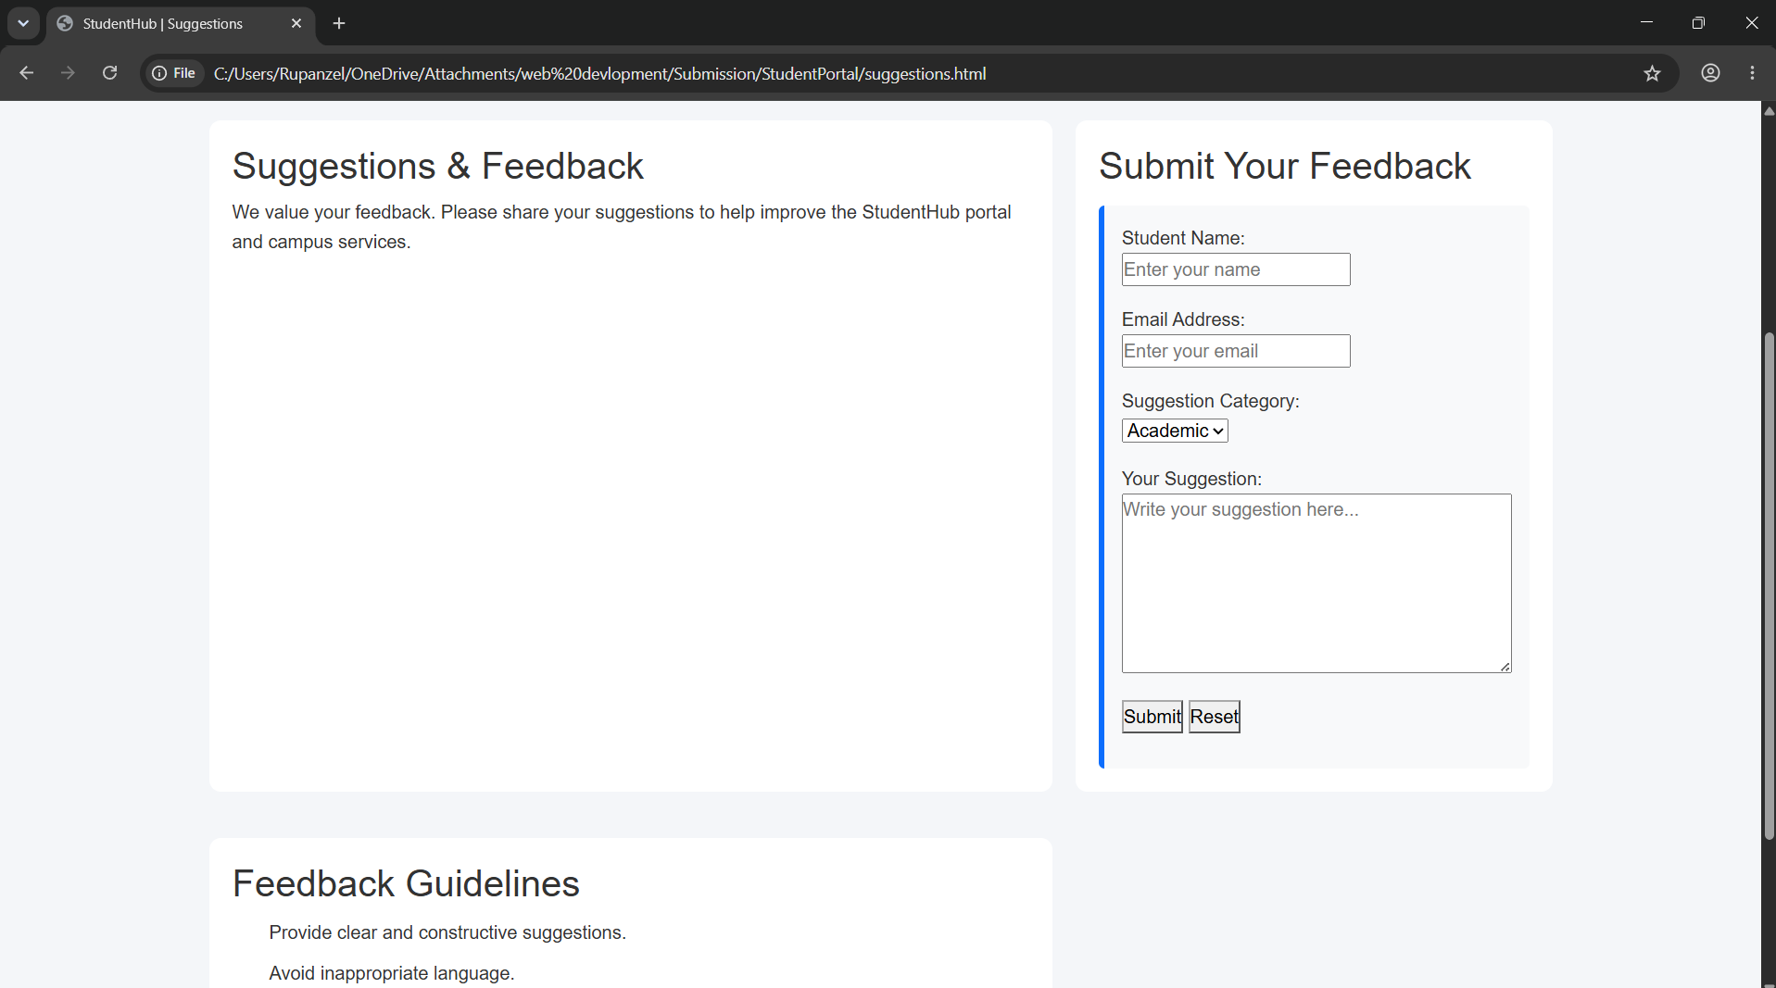

LEARNING OUTCOME:
After completing this practical, students will be able to develop a static multi-page StudentHub website using HTML5 semantic elements while maintaining a consistent and well-organized page structure. They will understand how to create accessible web pages by using proper headings, form labels, image alternative text, and navigation links. Students will also gain experience in linking multiple pages, organizing content effectively, and writing clean, readable, and standards-compliant HTML code that serves as a strong foundation for responsive and accessible web design.

